Task A (Optimization): The query SELECT * FROM Books WHERE Title = 'X' is slow. Write the SQL to create an index.
The query SELECT * FROM product WHERE product_name = 'X' is slow.
Write SQL to create an index.

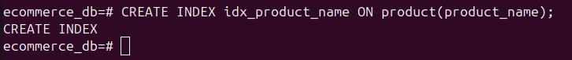
- Task B (Theory): Explain why creating an index on a boolean column like is_active (True/False) might NOT be efficient.

Why indexing a boolean column like is_active is usually NOT efficient

Creating an index on a boolean column (is_active = true/false) is not very useful because:
- Low selectivity
Only two values: true or false
Most rows usually share the same value
Index works best when values are mostly unique
- Query planner may ignore it
If 90% of rows are true, using the index gives no real benefit
Database will still scan most rows
- Extra overhead
Indexes slow down INSERT, UPDATE, and DELETE
Boolean index adds cost but little performance gain

